Elaboration Phase Specification

CIS 320-02

Team: Team Ace

Daniel Aguilar, Isaiah Collins, Alex Graf, Emmanuel Haynes, Shane Peterson, Mambuna Touray

Table Of Contents

System Requirements

Page 3

Use Case Descriptions, Use Case Diagrams, Sequence Diagrams

Page 6

Trace Matrix

Page 71

Class Diagram

Page 72

Database Diagram

Page 74

Database Definitions

Page 75

User Interface Navigation Diagram and Screen Layouts

Page 81

Data Capture Forms

Page 81

Elaboration Phase Prototypes

Page 82

Gantt Chart

Page 97

Cost Benefit Analysis

Page 98

System Requirements

Our system requirements describe the activities our system must be able to perform. These are the actions that we believe are crucial to include in our final product.

**Functional Requirements**

LogIn Page Requirements

ID: SR001 - The login page will allow for certain users to login into the website

ID: SR002 - The login page will allow for two factor authentication for all users

ID: SR003 - The login page will allow for VPN’s to be established on users devices

ID: SR004 - The login page will allow users to login anywhere at any time

Home Page Requiremen**ts**

ID: SR005-The home page will allow all information to be centralized / edited

ID: SR006 - The home page will allow for information to be stored

ID: SR007-The home page will allow data to be posted from managers…etc

ID: SR008-The home page will allow different paths to different functions based off needs

ID: SR009-The home page will allow data to be deleted if given permission

Previous Game Requirements

ID: SR010- The previous game page will allow previous game data to be created

ID SR011 - The previous game page will allow previous game film to be uploaded

ID SR012 - The previous game page will allow previous game data to be edited

ID SR013 - The previous game page will allow previous game data to be deleted

Event Page Requirements

ID SR014 - The event page will allow events to be created

ID SR015 - The event page will allow events to be edited

ID SR016 - The event page will allow events to be deleted

ID SR017 - The event page will allow event pictures to be uploaded

Player Page Requirements

ID SR018 - The player page will allow player profile to be edited

ID SR019 - The player page will allow player profiles to be created

ID SR020 - The player page will allow player information to be downloaded

ID SR021- The player page will allow for two factor authentication when accessing player information

ID SR022 - The player page will allow for player profiles to be deleted

Other Page Requirements

ID SR23 – The other page will allow practice footage to be uploaded

ID SR24 – The other page will allow practice footage to be deleted

ID SR25 – The other page will allow practice footage to be edited

Help Page Requirement

ID SR026 - The help page will allow help articles to be created

ID SR027 - The help page will allow help articles to be edited

ID SR028 - The help page will allow help articles to be deleted

ID SR029 - The help page will allow for directions on how to use certain features of the website

ID SR030 - The help page will allow for users to be redirected to a dedicated help desk team

**Non-Functional Requirements**

Performance Requirements

ID SR 031 - The website will load quickly

ID SR 032 - The website will run with no errors

ID SR 033- The website will be updated daily

Security Requirements

ID SR 034- The website will have an active firewall protecting the internals of the website

ID SR 035 - The website will function on a two factor authentication login system

ID SR 036 - The content management system will authenticate the web administrator

ID SR 037- The content management system will alert the web admins if there is a data breach and the lock website.

Capacity Requirements

ID SR038- content management system will be able to process and filter data efficiency

ID SR039 - the content management system will be able to hold large amounts of data

Availability Requirements

ID SR040- The website will be accessible at all times

ID SR041 - The website will allow display multiple tabs

ID SR042 - The website will adhere to W3C web accessibility standards

ID SR043 - The website will compatible with most devices

ID SR044 - The website will be compatible with most web browsers

ID SR045 - Website users will be able to sign up for the email newsletter

ID SR046 - Admins and other authorized users will be able to send out an email newsletter

Use Case Descriptions, Use Case Diagrams, Sequence Diagrams

# 1. Update/Edit Info (Use Cases 1-4)

**Use Case Descriptions:**

|  |  |  |
| --- | --- | --- |
| Use Case Name: Edit Website Info | ID: 01 | Importance Level: Low |
| Primary Actor: Admin. | | Use Case Type: Detail, Essential |
| Stakeholders and Interests:  Admin – wants to ensure all of the correct data is present  Website – used to view and manipulate data  Information Page – shows and displays information | | |
| Brief Description: This use case describes how administrators will edit information shown on the website. | | |
| Trigger: Administrator navigates to edit information page.  Type: Internal | | |
| Relationships:  Association: Administrators, website, information page  Include:  Extend: Edit info, Delete info  Generalization: | | |
| Normal Flow of Events:   1. The Administrator navigates to the website. 2. The Administrator logins to the website. 3. The Administrator navigates to the Player info page. 4. The Administrator clicks the edit info button. 5. The Administrator edits the information | | |
| SubFlows: | | |
| Alternate/Exceptional Flows: | | |

# 2. Update/Edit Info (Use Cases 1-4)

**Use Case Descriptions:**

|  |  |  |
| --- | --- | --- |
| Use Case Name: Upload Practice Information | ID: 02 | Importance Level: Medium |
| Primary Actor: Managers | | Use Case Type: Essential |
| Stakeholders and Interests:  Managers – want to load data to the website.  Website – used to upload, view and manipulate data.  Upload data page – used to upload data. | | |
| Brief Description: This use case describes how managers will upload data from recent practices and workouts | | |
| Trigger: Manager navigates to upload data page.  Type: Internal | | |
| Relationships:  Association: Managers, website, information page  Include:  Extend: Edit info, Delete info  Generalization: | | |
| Normal Flow of Events:  1. The Manager navigates to the website.  2. The Manager logins to the website.  3. The Manager navigates to the Player Info page.  4. The Manager clicks the “My Progress (On Court)” pane.  5. The Manager uploads the information | | |
| SubFlows: | | |
| Alternate/Exceptional Flows: | | |

# 3. Update/Edit Info (Use Cases 1-4)

**Use Case Descriptions:**

|  |  |  |
| --- | --- | --- |
| Use Case Name: Nutritionist Updates Player Meal Plan | ID: 03 | Importance Level: Medium |
| Primary Actor: Nutritionist | | Use Case Type: Essential |
| Stakeholders and Interests:  Nutritionist – changes Nutrition Plans for player.  Website – used to edit and view nutrition plans.  Nutrition Plan Page – used to view and change nutrition plans.  Player – view nutrition plans uploaded by nutritionists | | |
| Brief Description: This use case describes how nutritionists will edit the meal plans and provide advice to players | | |
| Trigger: Nutritionist clicks Nutrition plan link.  Type: Internal | | |
| Relationships:  Association: Nutritionists, website, nutrition page  Extend: Edit info, Delete info  Generalization: | | |
| Normal Flow of Events:   1. The Nutritionist navigates to the website. 2. The Nutritionist logins to the website. 3. The Nutritionist navigates to the Player Info page. 4. The Nutritionist clicks the “My Diet” pane. 5. The Nutritionist uploads the desired meal plan. | | |
| SubFlows: | | |
| Alternate/Exceptional Flows: | | |

# 4. Update/Edit Info (Use Cases 1-4)

**Use Case Descriptions:**

|  |  |  |
| --- | --- | --- |
| Use Case Name: Delete Data | ID: 04 | Importance Level: High |
| Primary Actor: Administrator | | Use Case Type: Essential |
| Stakeholders and Interests:  Administrator – deletes incorrect or irrelevant data.  Website – used to delete information.  Information Page – where data is found and can be deleted from. | | |
| Brief Description: This use case describes how administrators can delete data that they don’t need | | |
| Trigger: Administrator clicks delete information  Type: Internal | | |
| Relationships:  Association: Administrators, website, information page  Extend: Delete info  Generalization: | | |
| Normal Flow of Events:  1. The Administrators navigates to the website.  2. The Administrators logins to the website.  3. The Administrators navigates to the Player Info page.  4. The Administrators selects the data they would wish to delete.  5. The Administrators deletes data. | | |
| SubFlows: | | |
| Alternate/Exceptional Flows: | | |

**SEQUENCE DIAGRAM:**

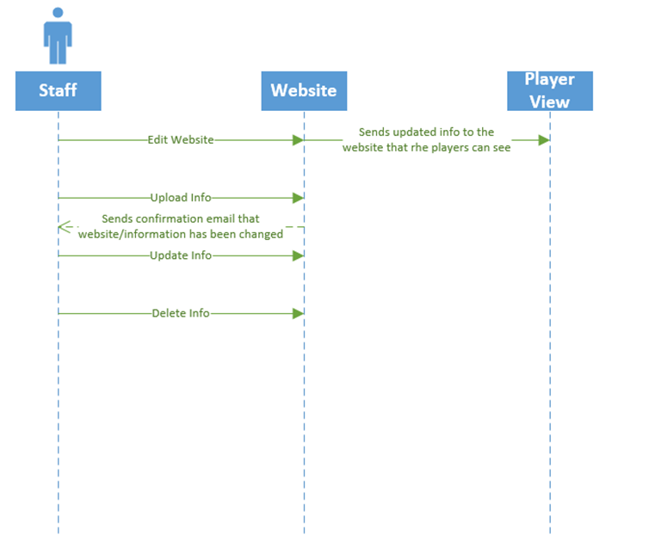

**USE CASE DIAGRAM:**

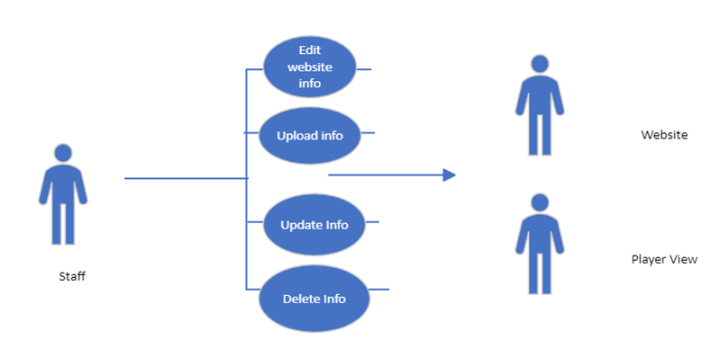

# 1. Edit Player Profile (Use Cases 5-7)

**Use Case Descriptions:**

|  |  |  |
| --- | --- | --- |
| Use Case Name: Create New Profile | ID: 05 | Importance Level: High |
| Primary Actor: Administrator | | Use Case Type: Essential |
| Stakeholders and Interests:  Administrator – creates new player profile.  Website – used to create and view current profiles.  Player Page – used to view and create profiles and add player information. | | |
| Brief Description: This use case describes how administrators can create new player profiles | | |
| Trigger: Administrator clicks create new player  Type: Internal | | |
| Relationships:  Association: Administrators, website, player page  Extend: Add Player info  Generalization: | | |
| Normal Flow of Events:  1. The Administrators navigates to the website.  2. The Administrators logins to the website.  3. The Administrators navigates to the Player Info page.  4. The Administrators clicks create new player.  5. The Administrators input player information. | | |
| SubFlows: | | |
| Alternate/Exceptional Flows: | | |

# 2. Edit Player Profile (Use Cases 5-7)

**Use Case Descriptions:**

|  |  |  |
| --- | --- | --- |
| Use Case Name: Delete Player Profile | ID: 06 | Importance Level: High |
| Primary Actor: Administrator | | Use Case Type: Essential |
| Stakeholders and Interests:  Administrator – deletes player profile.  Website – used to delete and view current profiles.  Player Page – used to view and delete profiles player profiles. | | |
| Brief Description: This use case describes how administrators can delete player profiles | | |
| Trigger: Administrator clicks delete player  Type: Internal | | |
| Relationships:  Association: Administrators, website, player page  Extend: Add Player info  Generalization: | | |
| Normal Flow of Events:  1. The Administrators navigates to the website.  2. The Administrators logins to the website.  3. The Administrators navigates to the Player Info page.  4. The Administrators clicks the Player info pane.  5. The Administrators deletes player. | | |
| SubFlows: | | |
| Alternate/Exceptional Flows: | | |

# 3. Edit Player Profile (Use Cases 5-7)

**Use Case Descriptions:**

|  |  |  |
| --- | --- | --- |
| Use Case Name: Player watches film | ID: 06 | Importance Level: Medium |
| Primary Actor: Player | | Use Case Type: Essential |
| Stakeholders and Interests:  Player – watches film.  Website – used to upload and watch film.  Player Page – used to view film. | | |
| Brief Description: This use case describes how a player can watch film. | | |
| Trigger: Player navigates to their player page and finds film they wish to watch  Type: Internal | | |
| Relationships:  Association: Player, website, player page  Extend: Watch team film  Generalization: | | |
| Normal Flow of Events:  1. The Players/staff navigates to the website.  2. The Players/staff logins to the website.  3. The Players/staff navigates to the Player Info page.  4. The Players/staff selects Previous Game tab.  5. The Players/staff watches film. | | |
| SubFlows: | | |
| Alternate/Exceptional Flows: | | |

**SEQUENCE DIAGRAM:**

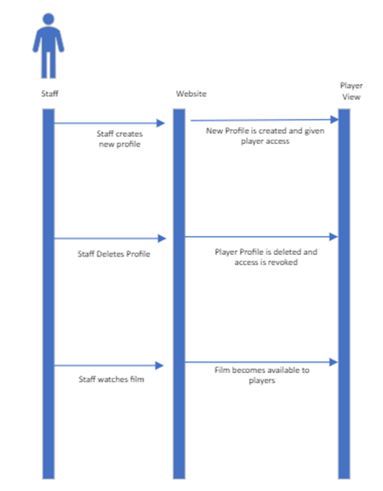

**USE CASE DIAGRAM:**

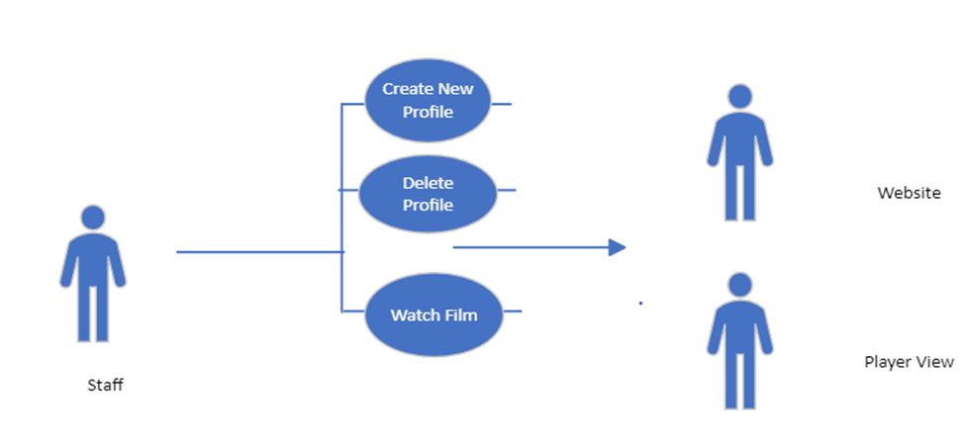

|  |  |  |
| --- | --- | --- |
| Use Case Name: Coach Wants to Review Film | ID: 08 | Importance Level: Medium |
| Primary Actor: Coach | | Use Case Type: Detail, Essential |
| Stakeholders and Interests:  Coach - wants to review game film.  Website - tool used to organize statistics and display film | | |
| Brief Description: This use case describes how the coach will review previous game film. | | |
| Trigger: Coach navigates to the previous game page on the website.  Type: Internal | | |
| Relationships:  Association: Coach  Include: Select Game  Extend:  Generalization: Display Film | | |
| Normal Flow of Events:   1. The coach will login to the website. 2. The system will authenticate the coach’s login credentials. 3. The coach navigates to the previous game page on the website. 4. The coach selects the game that they wish to watch. 5. The selected game film is displayed. | | |
| SubFlows: | | |
| Alternate/Exceptional Flows:  1a. The login page rejects the coach’s credentials.  1b. A pop-up message notifies the coach that the login credentials were incorrect. | | |

Use Case 8: Coach Wants to Review Film

Narrative: The coach reviews the game film in order to prepare for the current game they are going to play and the website sends back the information that the coach needs.

|  |  |  |
| --- | --- | --- |
| Use Case Name: Admin Needs to Login from Home Device | ID: 09 | Importance Level: High |
| Primary Actor: Administrator | | Use Case Type: Detail, Essential |
| Stakeholders and Interests:  Administrator - wants to login from home device.  Website - tool used to organize statistics and display film | | |
| Brief Description: This use case describes how an administrator logs in from a home device. | | |
| Trigger: Administrator wants to log in from home.  Type: External | | |
| Relationships:  Association: Administrator, Login System  Include: Single-Sign On, Native  Extend:  Generalization: | | |
| Normal Flow of Events:   1. The administrator navigates to the website. 2. The administrator chooses Single-Sign on or Native login. 3. The administrator enters their credentials. 4. The administrator is granted access to the website. | | |
| SubFlows: | | |
| Alternate/Exceptional Flows:  4a. The login system rejects the administrator’s credentials.  5a. A pop-up message notifies the administrator that the credentials were invalid and to try again.  6a. The credentials were rejected, and the administrator was not able to login. | | |

|  |  |  |
| --- | --- | --- |
| Use Case Name: Player Wants to Login from Mobile Device | ID: 10 | Importance Level: High |
| Primary Actor: Player | | Use Case Type: Detail, Essential |
| Stakeholders and Interests:  Player - wants to login from mobile device.  Website - tool used to organize statistics and display film | | |
| Brief Description: This use case describes how a player logs in from a mobile device. | | |
| Trigger: Player wants to log in on their smartphone.  Type: External | | |
| Relationships:  Association: Player, Login System  Include: Single-Sign On, Native  Extend:  Generalization: | | |
| Normal Flow of Events:   1. The player navigates to the website. 2. The player chooses Single-Sign on or Native login. 3. The player enters their credentials. 4. The player is granted access to the website. | | |
| SubFlows: | | |
| Alternate/Exceptional Flows:  4a. The login system rejects the player’s credentials.  5a. A pop-up message notifies the player that the credentials were invalid and to try again.  6a. The credentials were rejected, and the player was not able to login. | | |

|  |  |  |
| --- | --- | --- |
| Use Case Name: Coach Wants to Login from Home Device | ID: 11 | Importance Level: High |
| Primary Actor: Coach | | Use Case Type: Detail, Essential |
| Stakeholders and Interests:  Coach - wants to login from home device.  Website - tool used to organize statistics and display film | | |
| Brief Description: This use case describes how a coach logs in from a home device. | | |
| Trigger: Coach wants to log in from home.  Type: External | | |
| Relationships:  Association: Coach, Login System  Include: Single-Sign On, Native  Extend:  Generalization: | | |
| Normal Flow of Events:   1. The coach navigates to the website. 2. The coach chooses Single-Sign on or Native login. 3. The coach enters their credentials. 4. The coach is granted access to the website. | | |
| SubFlows: | | |
| Alternate/Exceptional Flows:  4a. The login system rejects the coach’s credentials.  5a. A pop-up message notifies the coach that the credentials were invalid and to try again.  6a. The credentials were rejected, and the coach was not able to login. | | |

Sequence Diagrams 9-11

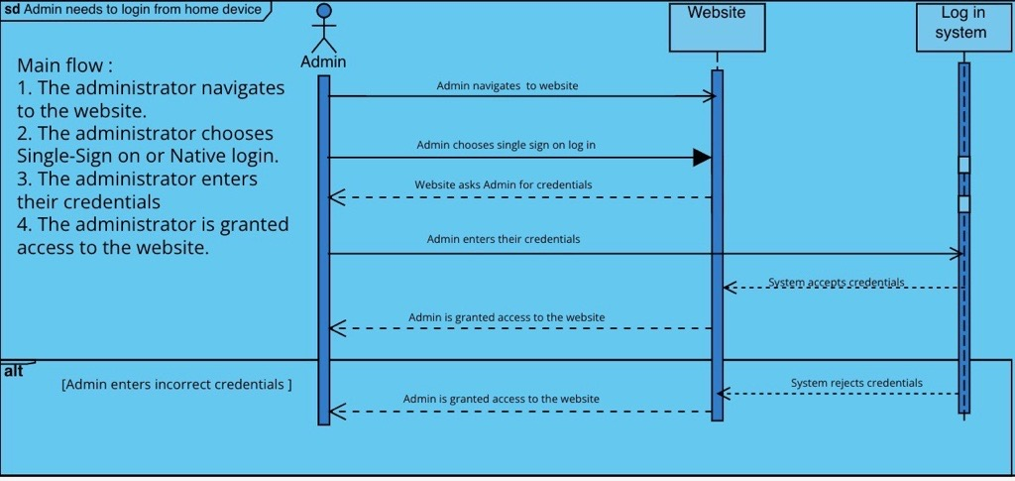

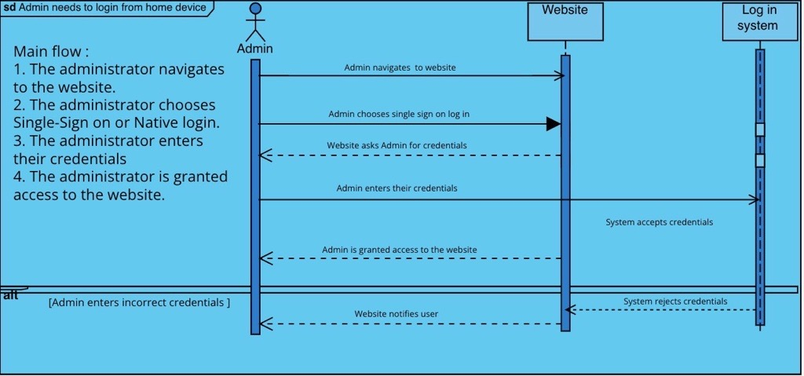

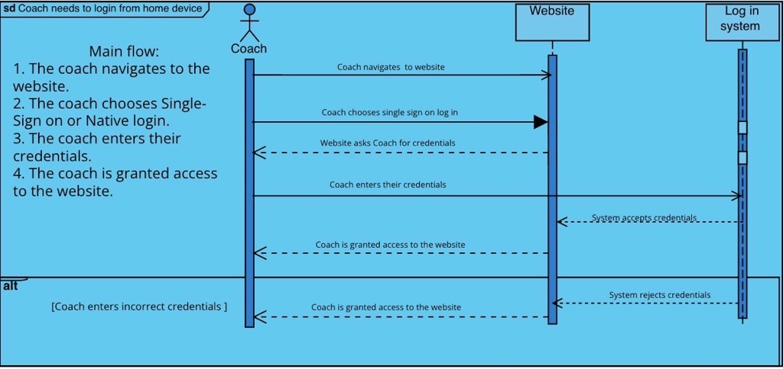

Use Case Diagram 9,10,11

Narrative: This allows users to login to the database from a mobile phone and from their personal computer.

|  |  |  |
| --- | --- | --- |
| Use Case Name: Create New Post in Feed | ID: 12 | Importance Level: High |
| Primary Actor: Administrator | | Use Case Type: Detail, Essential |
| Stakeholders and Interests:  Administrator - wants to make a new post to the news feed.  Website - tool used to organize statistics and display film | | |
| Brief Description: This use case describes how an administrator would make a new post to the news feed. | | |
| Trigger: Administrator navigates to the news feed page on the website.  Type: External | | |
| Relationships:  Association: Administrator  Include: Create post  Extend: Delete post, Edit post  Generalization: Create post in news feed | | |
| Normal Flow of Events:   1. The administrator navigates to the website. 2. The administrator enters their credentials and logs in to the website. 3. The administrator navigates to the News Feed page on the website. 4. The administrator clicks Create New Post. 5. The administrator includes what they want in the post. 6. The post is uploaded to the news feed. | | |
| SubFlows: | | |
| Alternate/Exceptional Flows:  6a. The post was not uploaded.  6b. A pop-up message notifies the administrator that the post was not uploaded and to try again. | | |



|  |  |  |
| --- | --- | --- |
| Use Case Name: Administrator Adds Previous Game Film | ID: 13 | Importance Level: High |
| Primary Actor: Administrator | | Use Case Type: Detail, Essential |
| Stakeholders and Interests:  Administrator - wants to add game film to the previous game  Website - tool used to upload the game film | | |
| Brief Description: Administrator adds previous game film on previous game tab. | | |
| Trigger: Administrator navigates to the previous game page on the website.  Type: Internal | | |
| Relationships:  Association: Administrator, Website    Include:  Extend: Watch Previous Game Film, Edit Previous Game Data  Generalization: | | |
| Normal Flow of Events:   1. The administrator navigates to the previous game page on the website. 2. The administrator selects the add game film button. 3. The administrator browses his files for the game film to be uploaded and selects it. 4. The administrator adds a caption or description. 5. The administrator clicks the “Save” button to upload the film. 6. A notification email is sent out to stakeholders notifying that a new game film has been posted. | | |
| SubFlows: | | |
| Alternate/Exceptional Flows:  7a. The file selected is an unsupported format and cannot be uploaded.  7b. A pop-up message notifies the administrator that the file cannot be uploaded because the format is unsupported. | | |

|  |  |  |
| --- | --- | --- |
| Use Case Name: Head Coach Watches Previous Game Film | ID: 14 | Importance Level: Low |
| Primary Actor: Coach | | Use Case Type: Detail, Essential |
| Stakeholders and Interests:  Coach - wants to watch the previous game film  Website - tool used to watch the game film | | |
| Brief Description: Head Coach watches previous game film on the plane heading to the next game in order to prepare for it. | | |
| Trigger: Administrator navigates to the previous game page on the website.  Type: Internal | | |
| Relationships:  Association: Coach, Website  Include:  Extend:  Generalization: | | |
| Normal Flow of Events:   1. The coach navigates to the previous game page on the website. 2. The coach selects game film button. 3. The coach plays the game film they’d like to watch. | | |
| SubFlows: | | |
| Alternate/Exceptional Flows:  5a. Film is unable to load, buffers.  5b. A pop-up message notifies the administrator that there was a problem loading the game film, to check his internet connection and try again. | | |

|  |  |  |
| --- | --- | --- |
| Use Case Name: Admin Edits Previous Game Data | ID: 15 | Importance Level: High |
| Primary Actor: Administrator | | Use Case Type: Detail, Essential |
| Stakeholders and Interests:  Administrator- may want to edit the previous game data.  Website - tool used to edit the previous game data | | |
| Brief Description: Admin wants to edits previous game data | | |
| Trigger: Administrator navigates to the previous game page on the website.  Type: Internal | | |
| Relationships:  Association: Administrator, Website  Include:  Extend: Add Previous Game Film  Generalization: Add Previous Game Data | | |
| Normal Flow of Events:   1. The administrator navigates to the previous game page on the website. 2. The administrator selects the “Edit Information” button. 3. The administrator selects the game they’d like to edit data on. 4. The administrator makes the necessary changes and clicks save. 5. A notification email is sent to stakeholders notifying them that a change has been made on a previous game. | | |
| SubFlows: | | |
| Alternate/Exceptional Flows:  4a. Invalid data is input into the edit event form, unable to save.  4b. A pop-up message notifies the administrator that the edit was not accepted and to try  again. | | |

**Use Case 13, 14 and 15 Sequence Diagram**

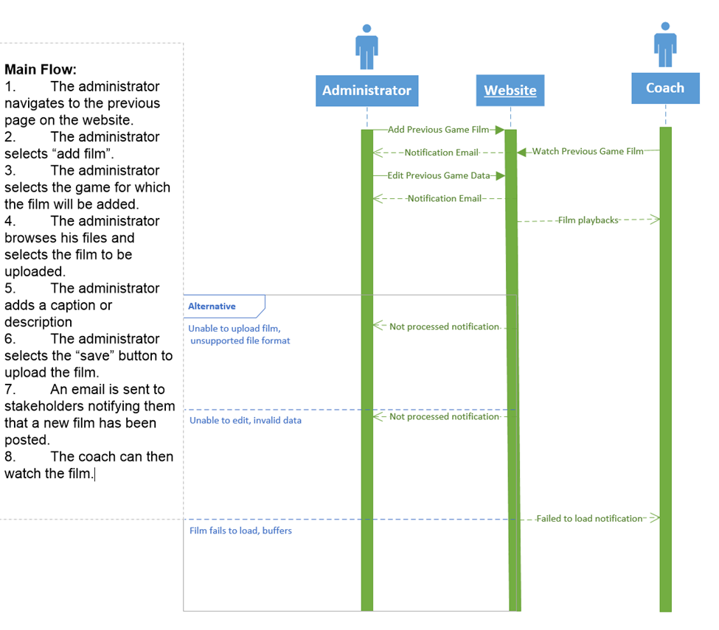

**Use Case 13, 14 and 15 Diagram**

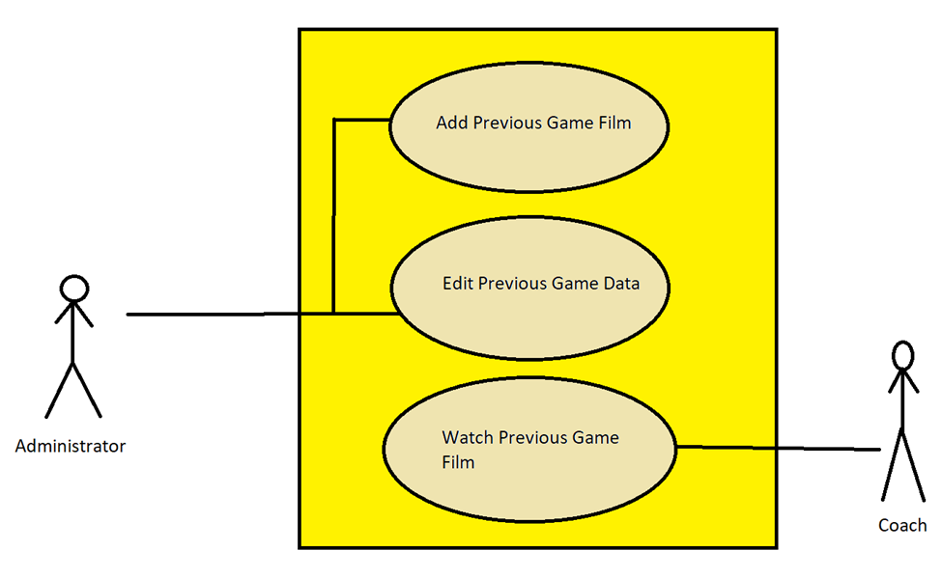

|  |  |  |
| --- | --- | --- |
| Use Case Name: Create New Event | ID: 16 | Importance Level: Medium |
| Primary Actor: Administrator | | Use Case Type: Detail, Essential |
| Stakeholders and Interests:  Administrator - wants to create an event  Website - tool used to create the event | | |
| Brief Description: This use case describes how events are created through the website. | | |
| Trigger: Administrator navigates to the events page on the website.  Type: Internal | | |
| Relationships:  Association: Administrator, Event, Website  Include:  Extend: Edit Event, Delete Event  Generalization: | | |
| Normal Flow of Events:   1. The administrator navigates to the events page on the website. 2. The administrator selects “create new event”. 3. The administrator inputs the necessary event information. 4. The administrator clicks “save”. 5. An email is sent out to stakeholders to notify of event. | | |
| SubFlows: | | |
| Alternate/Exceptional Flows:  4a. Invalid data is input into the create event form, unable to save.  5a. A pop-up message notifies the administrator that the event failed to be created. | | |

|  |  |  |
| --- | --- | --- |
| Use Case Name: Edit Event | ID: 17 | Importance Level: Medium |
| Primary Actor: Administrator | | Use Case Type: Detail, Essential |
| Stakeholders and Interests:  Administrator - Administrator may want to edit existing events  Website - tool used to edit event information | | |
| Brief Description: This use case describes how existing events are edited. | | |
| Trigger: Administrator navigates to the events page on the website.  Type: Internal | | |
| Relationships:  Association: Administrator  Include:  Extend:  Generalization: Edit Event | | |
| Normal Flow of Events:   1. The administrator navigates to the events page on the website. 2. The administrator clicks the “Edit Event” button to edit event information. 3. The administrator edits the necessary event information on the webpage. 4. The administrator clicks the “Save” button to process the edits. 5. The administrator is directed to a webpage verifying that the edit was accepted. 6. A confirmation email is sent to the administrator notifying them that an edit has been made. | | |
| SubFlows: | | |
| Alternate/Exceptional Flows:  5a. The edit was not processed.  5b. A pop-up message notifies the administrator that the edit was not accepted and to try again.  6a. An email is sent to the administrator notifying them that the event was not edited. | | |

|  |  |  |
| --- | --- | --- |
| Use Case Name: Delete Event | ID: 18 | Importance Level: Medium |
| Primary Actor: Administrator | | Use Case Type: Detail, Essential |
| Stakeholders and Interests:  Administrator - administrator may want to delete their existing event(s)  Website - tool used to collect event information | | |
| Brief Description: This use case describes how events are deleted. | | |
| Trigger: Administrator navigates to the events page on the website.  Type: Internal | | |
| Relationships:  Association: Administrator  Include:  Extend:  Generalization: Create Event | | |
| Normal Flow of Events:   1. The administrator navigates to the event page on the website. 2. The administrator clicks the “Delete Event” button to delete event information. 3. The administrator selects the event(s) on the webpage. 4. The administrator clicks the “Save” button to process the deletion. 5. The administrator is directed to a webpage verifying that the deletion was accepted. 6. A confirmation email is sent to the administrator notifying them that a deletion has been made. | | |
| SubFlows: | | |
| Alternate/Exceptional Flows:  5a. The deletion was not processed.  5b. A pop-up message notifies the administrator that the deletion was not accepted and to try again.  6a. An email is sent to the administrator notifying them that the event was not deleted. | | |

**Use Case 16,17 and 18 Sequence Diagram**

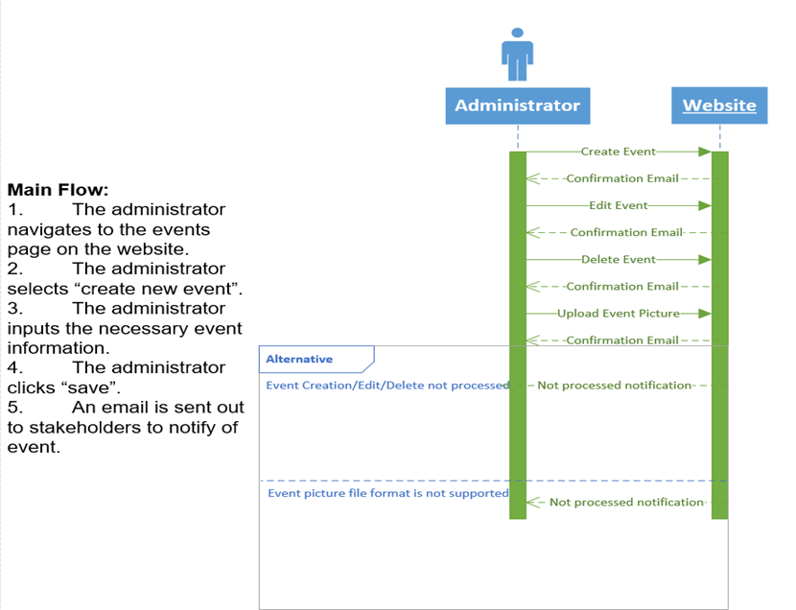

**Use Case 16, 17, and 18 Diagram**

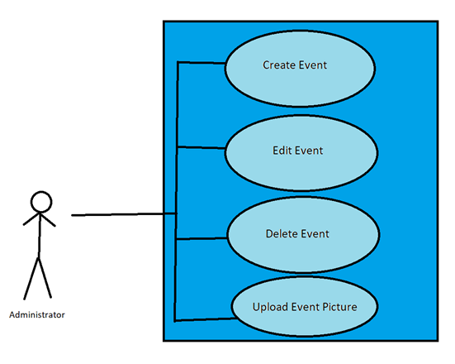

**Use Case 19:** Download Player Information

Primary Actor: Player

Description: Download a player’s information and statistics.

Risk Level: High

Use Case 19: Use case is triggered by the admin going into the events tabs and selecting Upload Event Pictures from the menu.

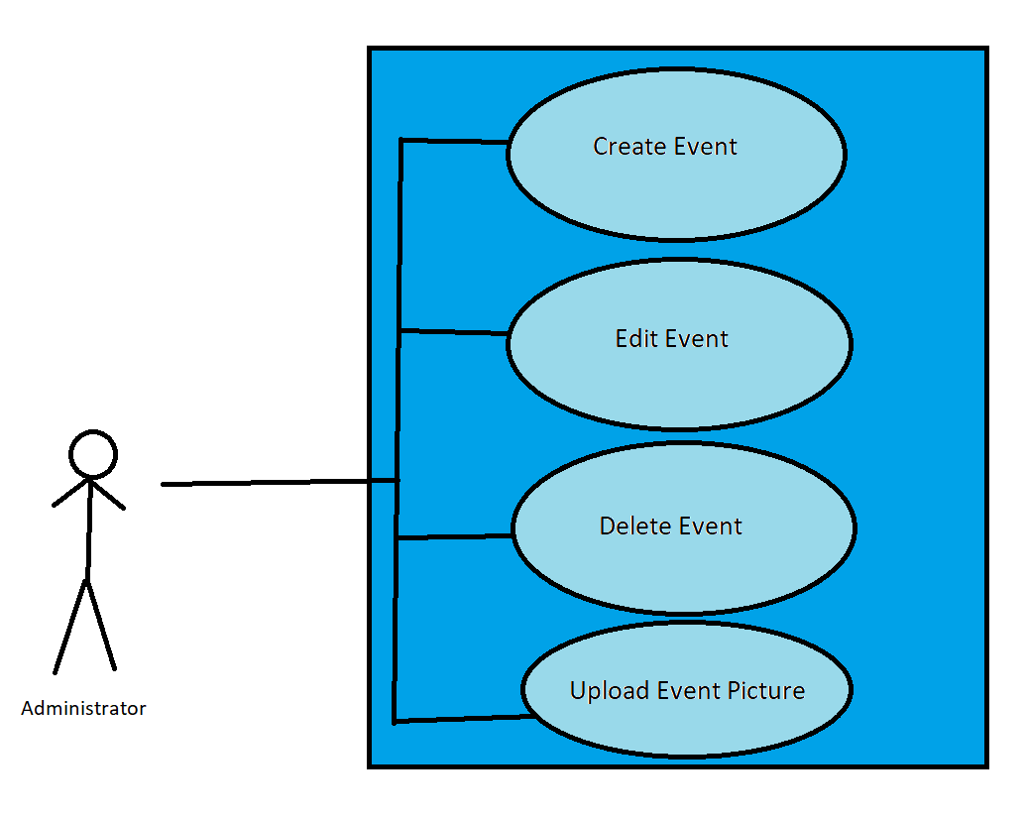

**Use Case 20**: Create Help Page Article

Primary Actor: Administrator

Description: New information needs to be posted to the Help Page.

Risk Level: Medium

**Use Case 21**: Edit Help Page Article

Primary Actor: Administrator

Description: Information on the Help Page needs to be edited.

Risk Level: Medium

**Use Case 28:** Delete Practice footage

Primary Actor: Admin

Description: Admin is able to delete old footage that is no longer needed.

Risk Level: Low

Use Case 20:Administrator Adds Previous Game Film, this use case is triggered by the admin going into the Previous Game tab and selecting Adds Previous Game Film from the menu. Use Case 21: Head Coach Watches Previous Game Film, this use case is triggered by the coach going into the previous game tab and selecting the previous game they would like to watch. Use Case 28: Admin Edits Previous Game Data, this use case is triggered by the admin going into the Previous Game tab and selecting Edit Previous Game Data from the menu.

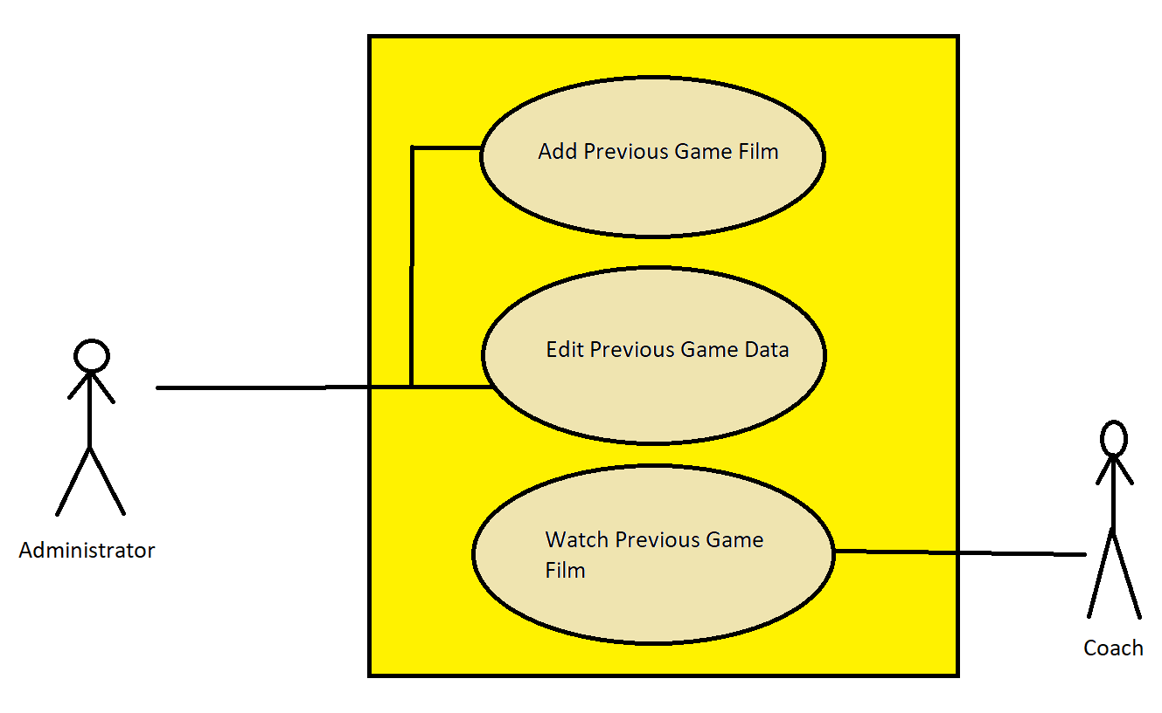

|  |  |  |
| --- | --- | --- |
| Use Case Name: Download Player Information | ID: 22 | Importance Level: High |
| Primary Actor: Coach | | Use Case Type: Detail, Essential |
| Stakeholders and Interests:  Coach- Would like to download player information  Athletic Trainer- Would like to view player information  Players- Would like to view their own information | | |
| Brief Description: This use cases describe the process of a coach downloading a players information and statistics | | |
| Trigger: Coach would like to download a copy of player profile  Type: External | | |
| Relationships:  Association: Coach  Include:  Extend:  Generalization: | | |
| Normal Flow of Events:   1. Coach navigates to Player Profile 2. Coach selects “Download profile” 3. System prompts Coach to enter a password to download 4. System prompt coach to select information to include on the download 5. System generates a PDF document containing the player’s selected information 6. System displays a message confirming the successful download of the PDF | | |
| SubFlows: | | |
| Alternate/Exceptional Flows:  3a. Coach inputs incorrect password  3b. Message pops up notifying the coach that the password was incorrect and to try again.  3c. If 3rd attempt password is incorrect coach is logged out  6a. Coach does not receive a PDF of player information | | |

|  |  |  |
| --- | --- | --- |
| Use Case Name: Create Help Page Article | ID: 23 | Importance Level: Medium |
| Primary Actor: Administrator | | Use Case Type: Detail, Essential |
| Stakeholders and Interests:  Administrator- Would like to create a help page that will assist stakeholders with navigating the website  Coach- Would like to view help page to find answers to questions they have  Athletic Trainer- Would like to view help page to find answers to questions they have  Nutritionists-Would like to view help page to find answers to questions they have  Players- Would like to view help page to find answers to questions they have | | |
| Brief Description: This use cases describe the process of an administrator creating a help page article | | |
| Trigger: The administrator identifies a need for a new help article based on user feedback.  Type: External | | |
| Relationships:  Association: Coach, Player,Nutritionist,Athletic Trainer  Include:  Extend: Edit Help page article, Delete Help page article  Generalization: Maintenance of other contents on the website | | |
| Normal Flow of Events:  1.Administrator navigates to Help page  2.Administrator selects “+” icon to create a new article  3.System generate a template for administrator to create a new article  4.Administrator fills template  5.Administrator designates where the article will go  6.Administrator selects publish  7.System published the Help page article on website  8.System confirms article was published | | |
| SubFlows: | | |
| Alternate/Exceptional Flows:  6a. If the administrator decides not to publish the article, they can save it as a draft and come back to it later. | | |

|  |  |  |
| --- | --- | --- |
| Use Case Name: Edit Help Page Article | ID: 24 | Importance Level: High |
| Primary Actor: Administrator | | Use Case Type: Detail, Essential |
| Stakeholders and Interests:  Administrator- Would like to edit help page to ensure that information is accurate  Coach- Would like to view help page to find correct answers to questions they have  Athletic Trainer- Would like to view help page to find correct answers to questions they have  Nutritionists-Would like to view help page to find correct answers to questions they have  Players- Would like to view help page to find correct answers to questions they have | | |
| Brief Description: This use cases describe the process of an administrator editing a help page article | | |
| Trigger: The administrator identifies a need to edit the help page article due to an error  Type: External | | |
| Relationships:  Association: Coach, Player, Nutritionist, Athletic Trainer  Include: Delete Help page article  Extend:  Generalization: Maintenance of other contents on the website, Create Help page article | | |
| Normal Flow of Events:  1. Administrator is made aware of an error in help page article  2.Administrator navigates to Help page  3.Administrator selects the “pencil” icon to be in edit mode  4.Administrator selects the article they would like to edit  5.Administrator edits help page article  6.Administrator selects “publish”  7.Administrator confirms changes  8. Administrator publishes the new help page article  9.System confirms changes were saved and published | | |
| SubFlows: | | |
| Alternate/Exceptional Flows:  6a. Administrator selects ”cancel” and is redirected to the main screen  6b. System notifies administrator  7a. Administrator does not confirm changes and is revises the edit  7b. Administrator revises edit and confirms changes | | |

|  |  |  |
| --- | --- | --- |
| Use Case Name: Delete Help Page Article | ID: 25 | Importance Level: Medium |
| Primary Actor: Administrator | | Use Case Type: Detail, Essential |
| Stakeholders and Interests:  Administrator: Wants to remove outdated or irrelevant help page articles to maintain a clean and helpful website.  Coach: May rely on the help page articles for information and may need to be informed of any changes or updates.  Athletic Trainer: May rely on the help page articles for information and may need to be informed of any changes or updates.  Nutritionist: May rely on the help page articles for information and may need to be informed of any changes or updates.  Player: May rely on the help page articles for information and may need to be informed of any changes or updates. | | |
| Brief Description: This use case describes the process of an administrator deleting a help page article from the website. | | |
| Trigger: The administrator identifies a need to delete the help page article due to it being outdated or irrelevant.  Type: External | | |
| Relationships:  Association: Coach, Player, Nutritionist, Athletic Trainer  Include:  Extend: Edit Help Page  Generalization: Maintenance of other contents on the website, Create Help page article | | |
| Normal Flow of Events:  1.Administrator navigates to the Help page.  2.Administrator selects the delete icon on the article.  3.Administrator selects the article they would like to delete.  4.System prompts the administrator to confirm deletion.  5.Administrator selects "confirm."  6.System deletes the help page article from the website.  7. System confirms deletion | | |
| SubFlows: | | |
| Alternate/Exceptional Flows:  4a. If the administrator selects "cancel" instead of "confirm," the article is not deleted.  5a. If the administrator does not select "confirm," the article is not deleted  6a. If the system encounters an error while deleting the article, the administrator is prompted with an error message. | | |

|  |  |  |
| --- | --- | --- |
| Use Case Name: Speak to a help desk representative | ID: 26 | Importance Level: Low |
| Primary Actor: Coach | | Use Case Type: Detail, Essential |
| Stakeholders and Interests:  Coach-Would like to seek help for issue they are facing  Administrator- Would like to ensure coach’s problem is resolved | | |
| Brief Description: This use case describes the process of a coach contacting a help desk representative to seek assistance with a technical issue. | | |
| Trigger: Coach encounters an issue while using the website  Type: External | | |
| Relationships:  Association: Administrator  Include:  Extend:  Generalization: | | |
| Normal Flow of Events:   1. Coach navigates to the “help” tab 2. Coach selects “contact us” 3. Systems presents the coach with two support options “Wordpress support” or “UofL IT support” 4. Coach selects “UofL IT support” 5. System presents coach with three options “ Make a request”, “LiveChat”, “Phone” 6. Coach selects “Live chat” 7. Coach is entered in Queue for available help desk representative 8. Administrator assists coach with their issue 9. Coach’s issue is resolved 10. Administrator closes chat | | |
| SubFlows: | | |
| Alternate/Exceptional Flows:  5a. Coach selects "Phone" instead of "LiveChat" .  5b.The system provides the coach with a phone number to call.  5c.The coach contacts the help desk representative via phone.  5d.Administrator assists coach with their issue  5e.Coach’s issue is resolved  5f.Coach ends call | | |

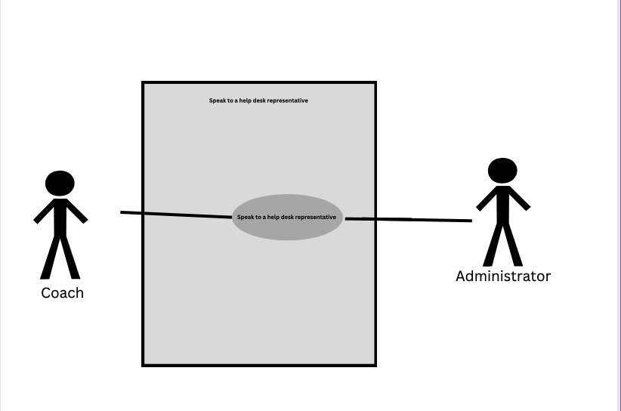

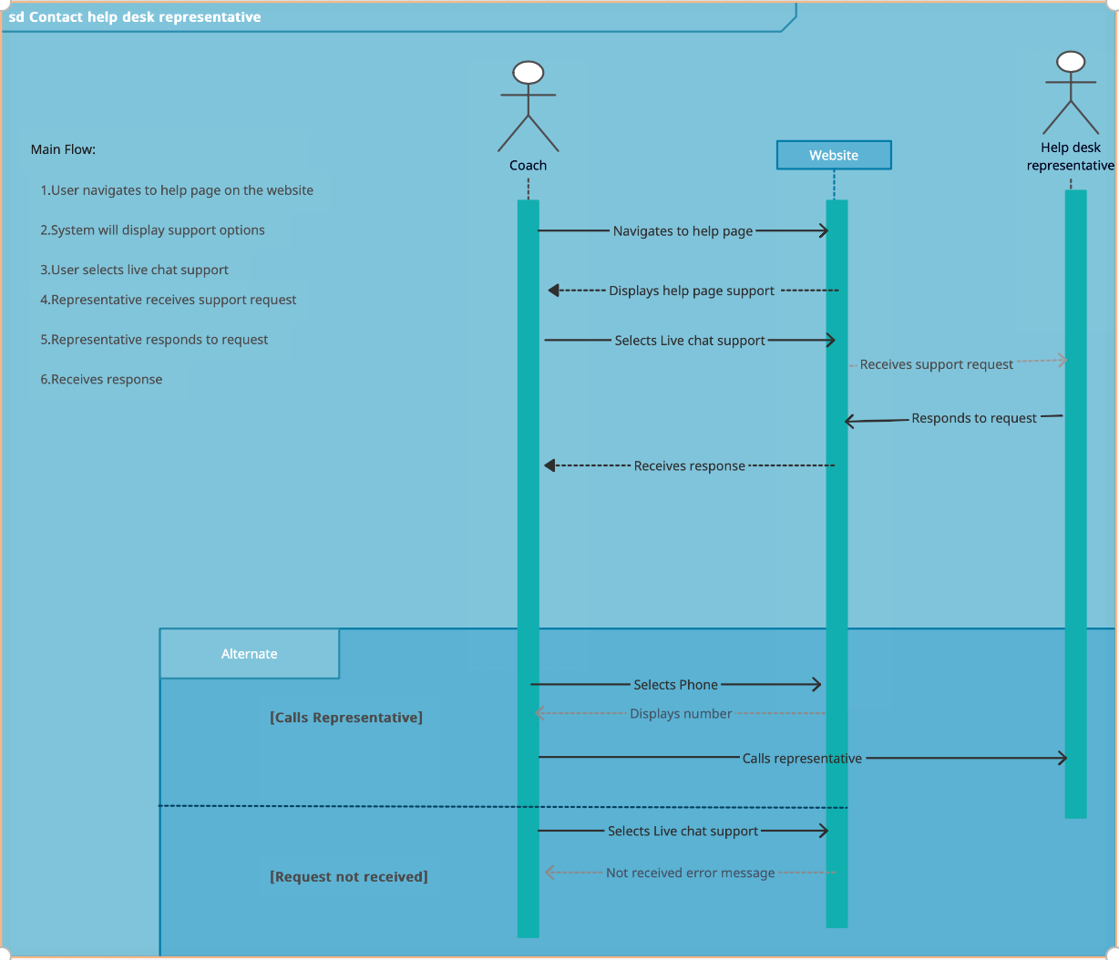

|  |  |  |
| --- | --- | --- |
| Use Case Name: Send Email Newsletter | ID: 27 | Importance Level: High |
| Primary Actor: Administrator | | Use Case Type: Detail, Essential |
| Stakeholders and Interests:  Administrator- Would like to send one email to all stakeholders  Coaches- Would like to stay up to date with news from administrator  Athletic Trainer- Would like to stay up to date with news from administrator  Players- Would like to stay up to date with news from administrator  Nutritionists- Would like to stay up to date with news from administrator | | |
| Brief Description: This use cases describe the process of an administrator sending a newsletter to all distribution list subscribers. | | |
| Trigger: Shopper navigates to the store page on the website.  Type: External | | |
| Relationships:  Association: Coach, Athletic trainers, players, nutritionists  Include:  Extend:  Generalization: | | |
| Normal Flow of Events:  1.Administrator navigates to “User” tab  2.Administrator selects “send email”  3.Administrator selects “send to all users’  4.Administrator types email  5.Administrator presses “send” button  6.Email is sent to all users  7.Administrator receives a confirmation email | | |
| SubFlows: | | |
| Alternate/Exceptional Flows:  6a. Email is not sent  6b. Administrator does not receive a confirmation email  6c.Administrator reviews email  6d.Administrator presses “send” button  6e.Email is sent  6f.Administrator receives confirmation email | | |

|  |  |  |
| --- | --- | --- |
| Use Case Name: Nutritionist Has New Player Diet Recommendation | ID: 29 | Importance Level: High |
| Primary Actor: Nutritionist | | Use Case Type: Detail, Essential |
| Stakeholders and Interests:  Nutritionists – Wants to add new data to player profile.  Coach- Would like to view player diet recommendation  Player-Would like to view diet recommendation  Website - Tool used to collect nutritionists’ new data | | |
| Brief Description: This use case describes how a nutritionist would add a new diet recommendation to a player profile | | |
| Trigger: Nutritionist reviews player data and has a new diet recommendation.  Type: External | | |
| Relationships:  Association: Nutritionist  Include:  Extend:  Generalization: | | |
| Normal Flow of Events:  1. The nutritionists navigate to the player profile page on the website.  2. The nutritionists clicks “note”  3. The nutritionist clicks the “+” icon to post new note.  4. The nutritionist enters subject and diet recommendation  5. The nutritionists clicks post  6.The system confirms notes has been posted.  7.Coaches and players can now view post. | | |
| SubFlows: | | |
| Alternate/Exceptional Flows:  5a. The nutritionist clicks discard  5b. The note is deleted  6a. The system displays an error message.  6b.The nutritionist attempts to post the note again.  6c. The note is posted | | |

|  |  |  |
| --- | --- | --- |
| Use Case Name: Admin Needs to Delete Previous Physical Data | ID: 30 | Importance Level: High |
| Primary Actor: Admin | | Use Case Type: Detail, Essential |
| Stakeholders and Interests:  Admin – wants to delete previous physical data.  Website - tool used to collect nutritionists’ new data | | |
| Brief Description: Admin deletes previous physical data because of error. | | |
| Trigger: Admin goes into the player profile and navigates to previous physical data and deletes previous data used.  Type: Internal | | |
| Relationships:  Association: Admin  Include: Delete Physical Data  Extend: Edit Player Profile  Generalization: Delete Physical Data | | |
| Normal Flow of Events:   1. The admin navigates to the player profile page. 2. The admin clicks edit physical data. 3. The admin selects data that needs to be deleted and hits the delete button. 4. A pop-up message appears with the message, “Are you sure that you want to delete?”. 5. The admin clicks yes and deletes all the selected data and clicks done. 6. The admin closes out of the tab and logouts. | | |
| SubFlows: | | |
| Alternate/Exceptional Flows:  1a. The admin tries to bypass the “Are you sure you want to delete?” popup, but the popup will remain.  2a. A pop-up message notifies the admin that they need to logout before they close out of the data. | | |

|  |  |  |
| --- | --- | --- |
| Use Case Name: Admin Uploads Medical Data to Player Profiles | ID: 37 | Importance Level: High |
| Primary Actor: Admin | | Use Case Type: Detail, Essential |
| Stakeholders and Interests:  Admin – wants to upload medical data.  Website - tool used to collect nutritionists’ new data | | |
| Brief Description: Admin uploads medical data to player profile. | | |
| Trigger: Admin goes into the player profile and navigates to previous physical data and deletes previous data used.  Type: Internal | | |
| Relationships:  Association: Admin  Include: Delete Physical Data  Extend: Edit Player Profile  Generalization: Delete Physical Data | | |
| Normal Flow of Events:   1. The admin navigates to the player profile page. 2. The admin clicks edit physical data. 3. The admin selects data that needs to be deleted and hits the delete button. 4. A pop-up message appears with the message, “Are you sure that you want to delete?”. 5. The admin clicks yes and deletes all the selected data and clicks done. 6. The admin closes out of the tab and logouts. | | |
| SubFlows: | | |
| Alternate/Exceptional Flows:  3a. The admin tries to leave the website without hitting done, and a popup will pop up to tell them to hit done and save the work.  4a. A pop-up message notifies the admin that they need to logout before they close out of the data. | | |

**Use Case Descriptions**

|  |  |  |
| --- | --- | --- |
| Use Case Name: Coach Wants to View Players PPG from Last 5 Games | ID: 31 | Importance Level: Medium |
| Primary Actor: Coach | | Use Case Type: Detail, Essential |
| Stakeholders and Interests:  Coach – wants to view players ppg from last 5 games.  Website - tool used to collect nutritionists’ new data | | |
| Brief Description: Coach needs to view El Ellis’s PPG from last five games | | |
| Trigger: Coach goes into the previous game tab and clicks view previous game. He clicks on El Ellis’s name and views his ppg stats.  Type: Internal | | |
| Relationships:  Association: Coach  Include:  Extend: View Player Stats  Generalization: View Player stats | | |
| Normal Flow of Events:   1. The coach navigates to the previous game page. 2. The coach clicks specific player name 3. The website pulls up a new page with the select player’s last five game stats. 4. The coach takes notes of what he needs from PPG stat. 5. The coach closes out of the tab and logouts. | | |
| SubFlows: | | |
| Alternate/Exceptional Flows:  5a. The coach tries to leave the website without logging out, popup message displays, “Please logout.” | | |

|  |  |  |
| --- | --- | --- |
| Use Case Name: Coach Wants To View Shot Spread and Shot Selection | ID: 32 | Importance Level: High |
| Primary Actor: Coach | | Use Case Type: Detail, Essential |
| Stakeholders and Interests:  Coach – wants to view shot spread and shot selection.  Website - tool used to display shot spread and shot selection new data | | |
| Brief Description: Coach wants to view team shot selection spread from last game | | |
| Trigger: Coach goes into the previous game tab and clicks view previous game. He clicks on shot selection section, and the website displays the shot spread from the previous game.  Type: Internal | | |
| Relationships:  Association: Coach  Include:  Extend: View Shot Spread and Shot Selection  Generalization: View Shot Spread and Shot Selection | | |
| Normal Flow of Events:   1. The coach navigates to the previous game page. 2. The coach clicks on shot selection tab. 3. The website pulls up a new page with the teams shot spread breakdown from the previous game. 4. The coach takes notes of what he needs from the team shot spread breakdown. 5. The coach closes out of the tab and logouts. | | |
| SubFlows: | | |
| Alternate/Exceptional Flows:  4a. The coach tries to leave the website without logging out, popup message displays, “Please logout.”  5a. The coach tries to access the website on the plane without confirming with DUO’s two factor authentication, error message “Please confirm with DUO before logging in.” displays. | | |

|  |  |  |
| --- | --- | --- |
| Use Case Name: Coach Wants To View Top Performer From Last Game | ID: 33 | Importance Level: High |
| Primary Actor: Coach | | Use Case Type: Detail, Essential |
| Stakeholders and Interests:  Coach – wants to view top performer from last game  Website - tool used to display top performer from the last game | | |
| Brief Description: Coach wants to go through team stats and identify the top performer from the previous game | | |
| Trigger: Coach goes into the previous game tab and clicks view previous game. The website displays the game stats as well as the top performer from the previous game.  Type: Internal | | |
| Relationships:  Association: Coach  Include:  Extend: View Previous Games  Generalization: View Previous Game | | |
| Normal Flow of Events:   1. The coach navigates to the previous game page. 2. The website displays all the previous game stats for both teams, as well as the top performer. 3. The coach takes notes of what he needs from the top performer’s stats. 4. The coach closes out of the tab and logouts. | | |
| SubFlows: | | |
| Alternate/Exceptional Flows:  6a. The coach tries to leave the website without logging out, popup message displays, “Please logout.”  7a. The coach tries to access the website on the plane without confirming with DUO’s two factor authentication, error message “Please confirm with DUO before logging in.” displays. | | |

|  |  |  |
| --- | --- | --- |
| Use Case Name: Coach Wants To Identify Players Free Throw Percentage From Last 5 Games | ID: 34 | Importance Level: High |
| Primary Actor: Coach | | Use Case Type: Detail, Essential |
| Stakeholders and Interests:  Coach – wants to view players free throw percentage from last 5 games.  Website - tool used to display free throw percentage from the 5 last games | | |
| Brief Description: Coach wants to identify players free throw percentage from last 5 games . | | |
| Trigger: Coach goes into the previous game tab and clicks view previous game. The website displays the game stats. Coach clicks on a player’s name and navigates to their free throw percentage.  Type: Internal | | |
| Relationships:  Association: Coach  Include:  Extend: View Shot Spread and Shot Selection  Generalization: View Shot Spread and Shot Selection | | |
| Normal Flow of Events:   1. The website displays all the previous game stats for both teams. 2. The coach clicks on a player’s name. 3. The website displays players stats from last five games. 4. The coach navigates to his free throw percentage and makes note of it. 5. The coach closes out of the tab and logouts. | | |
| SubFlows: | | |
| Alternate/Exceptional Flows:  8a. The coach tries to leave the website without logging out, popup message displays, “Please logout.”  9a. The coach tries to access the website on the plane without confirming with DUO’s two factor authentication, error message “Please confirm with DUO before logging in.” displays. | | |

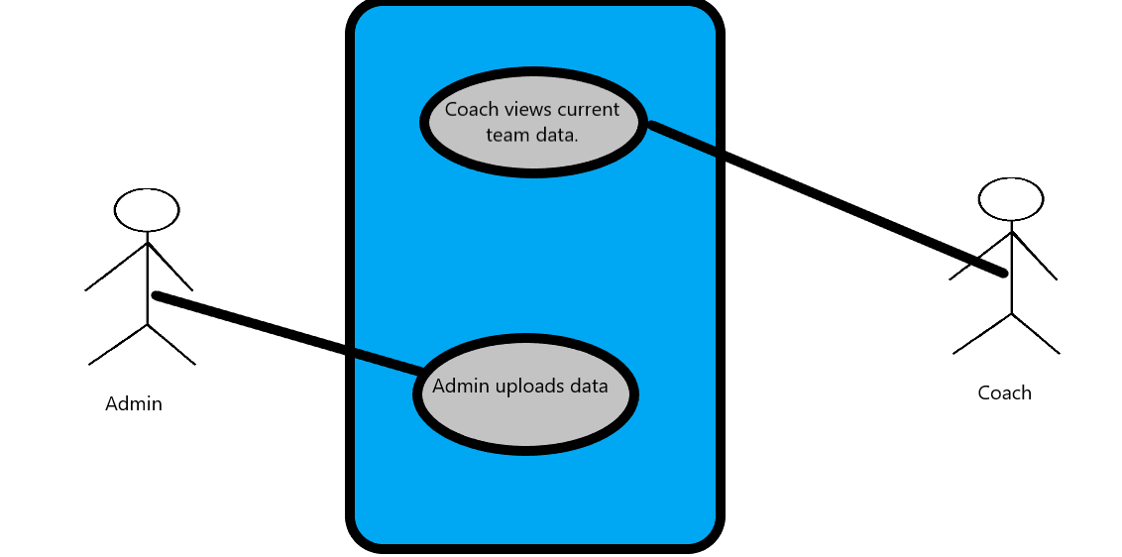  
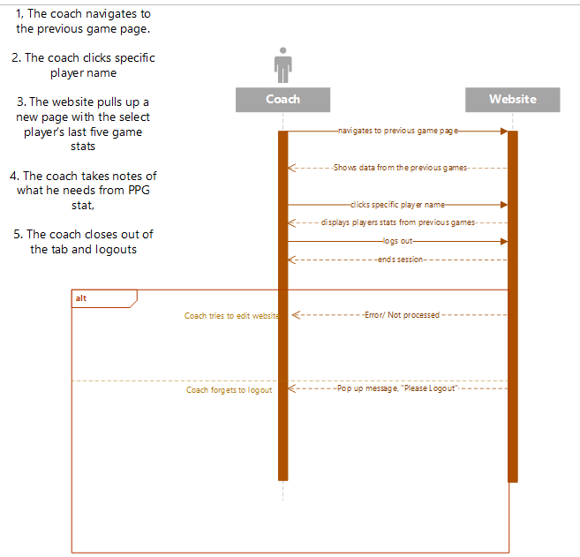

|  |  |  |
| --- | --- | --- |
| Use Case Name: Coach Wants to View Opponents Top Performer for Current Game | ID: 35 | Importance Level: High |
| Primary Actor: Coach | | Use Case Type: Detail, Essential |
| Stakeholders and Interests:  Coach – wants to view opponents’ top performer for current game  Website - tool used to display opponent’s top performer for current game | | |
| Brief Description: Coaching staff wants to view opponent’s top performer for current game to create game plan for the current game. | | |
| Trigger: Coach goes into the current game tab and clicks view current game. The website displays the current game match while highlighting the top performer or player to watch.  Type: Internal | | |
| Relationships:  Association: Coach  Include:  Extend: View Top Performer  Generalization: View Current Game | | |
| Normal Flow of Events:   1. The coach navigates to the current game page. 2. The website displays the current game matchup as well as their stats and top performer/ player to watch. 3. The coach takes notes of what he needs from the top performer’s stats. 4. The coach closes out of the tab and logouts. | | |
| SubFlows: | | |
| Alternate/Exceptional Flows:  10a. The coach tries to leave the website without logging out, popup message displays, “Please logout.”  11a. The coach tries to access the website on the plane without confirming with DUO’s two factor authentication, error message “Please confirm with DUO before logging in.” displays. | | |

|  |  |  |
| --- | --- | --- |
| Use Case Name: Admin Adds Current Opponents Team Information To Database | ID: 36 | Importance Level: High |
| Primary Actor: Admin | | Use Case Type: Detail, Essential |
| Stakeholders and Interests:  Admin – wants to add current opponents team information to database.  Website - tool used to add data to current game tab | | |
| Brief Description: Admin adds current opponents team information to the database to be used for review | | |
| Trigger: Admin goes into the current game tab and clicks add new current game data. He inputs his unique login, and adds new current game data. After he/she is done, they click done and logout.  Type: Internal | | |
| Relationships:  Association: Admin  Include: Add new data to current game tab  Extend: Add new data  Generalization: Add Current Game | | |
| Normal Flow of Events:   1. The admin navigates to the current game page. 2. The admin clicks add new current game data. 3. The admin inputs unique login and adds new login data. 4. When finished, the admin clicks done. 5. The admin closes out of the tab and logouts. | | |
| SubFlows: | | |
| Alternate/Exceptional Flows:  12a. The admin tries to leave the website without hitting done, and a popup will pop up to tell them to hit done and save the work.    13a. A pop-up message notifies the admin that they need to logout before they close out of the data.    14a. The admin tries to access the website on the plane without confirming with DUO’s two factor authentication, error message “Please confirm with DUO before logging in.” displays. | | |

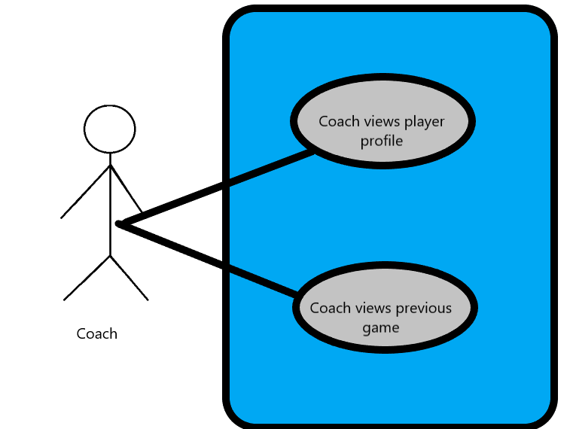

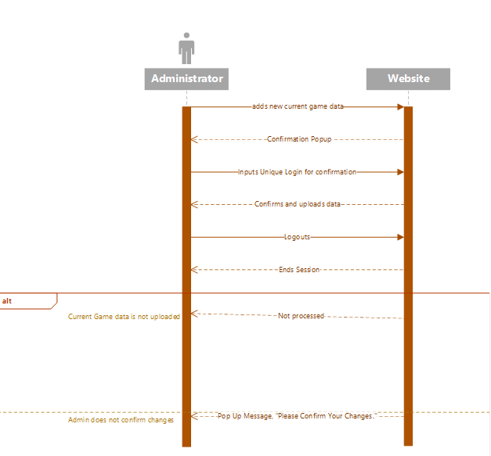

|  |  |  |
| --- | --- | --- |
| Use Case Name: Upload Practice footage | ID: 38 | Importance Level: High |
| Primary Actor: Administrator | | Use Case Type: Detail |
| Stakeholders and Interests:  Admin - wants to upload practice footage.  Coach - tool used to review player performance and plan accordingly.  Player – Wants to find things to improve on before the game, correct bad habits.  UofL Basketball team - tool that can be used in film sessions to improve overall team performance. | | |
| Brief Description: This use case describes how practice footage is uploaded to be used as a tool for players and coaches. | | |
| Relationships:  Association: Coach, Player, Admin  Include: UofL Basketball Team  Extend: Edit Practice footage, Delete Practice Footage | | |
| Normal Flow of Events:   1. Cameraman records practice. 2. Administrator receives footage from Film crew. 3. Admin uploads practice video to team portal for Coaches to access. 4. Admin edits practice video into segments to make it digestible for coach. (drills, scrimmage,etc.) 5. Coach is able to highlight key moments in film session. 6. Player is able to see moments highlighted by coach. 7. Practice footage is critiqued and used to improve performance. | | |

|  |  |  |
| --- | --- | --- |
| Use Case Name: Edit Practice Footage | ID: 39 | Importance Level: High |
| Primary Actor: Admin | | Use Case Type: Essential |
| Stakeholders and Interests:  Admin – Administrator needs to make video easy for coach to use as a tool.  Coach – Needs to be able to easily recall to specific moments in practice. | | |
| Brief Description: This use case describes how the Administrator will edit the Practice footage into segments. | | |
| Relationships:  Association: Admin  Extend: Coach  Generalization: Edit Footage | | |
| Normal Flow of Events:   1. The Admin uploads Practice footage. 2. The Admin splits the footage into segments and names them accordingly. 3. The Admin makes the edited footage viewable for coaches. 4. Coaches view practice footage. 5. Coaches use practice footage to point out teachable moments and mistakes to players. | | |

|  |  |  |
| --- | --- | --- |
| Use Case Name: Delete Practice Footage | ID: 40 | Importance Level: Medium |
| Primary Actor: Administrator | | Use Case Type: Detail |
| Stakeholders and Interests:  Admin - Admin may want to delete old practice footage.  Coach – Coach may want old footage deleted to avoid confusion. | | |
| Brief Description: This use case describes how old practice footage can be deleted. | | |
| Relationships:  Association: Admin  Include:  Extend:  Generalization: Delete Footage | | |
| Normal Flow of Events:   1. The admin goes back through previous uploads. 2. The admin deletes footage when season ends. 3. The footage is no longer public on portal and is sent to archives. | | |
| Alternate/Exceptional Flows:  4a. The coach asks for a piece of footage to be deleted.  4b. Admin deletes at coaches’ discretion. | | |

|  |  |  |
| --- | --- | --- |
| Use Case Name: Add Note | ID: 41 | Importance Level: Medium |
| Primary Actor: Coach | | Use Case Type: Detail |
| Stakeholders and Interests:  Coach - wants to add a note for players and other coaches to see.  Website - tool used to add notes.  Previous Game Page – Page where notes can be added.  Current Game page (Gameplan) – Page where notes can be added | | |
| Brief Description: This use case allows for coaches to add specific notes pertaining to specific pages to provide feedback to other members. | | |
| Relationships:  Association: Coaches, Players  Include:  Extend: Edit Note, Delete Note  Generalization: | | |
| Normal Flow of Events:   1. The Coach Analyzes Website date. (Videos, stats, etc.) 2. Coach clicks on specific page. 3. Coach selects add note. 4. Coach Types note 5. Coach Publishes Note 6. Other coaches/players read notes. 7. Corrections are made based off notes. | | |
| Alternate/Exceptional Flows:  7a. Other coach has option to comment back and add additional notes. | | |

|  |  |  |
| --- | --- | --- |
| Use Case Name: Edit Note | ID: 42 | Importance Level: Low |
| Primary Actor: Coaches | | Use Case Type: Detail, Essential |
| Stakeholders and Interests:  Coach – wants to edit previous note to add additional insight they may have forgot initially.  Website- allows for old notes to be updated. | | |
| Brief Description: This use case allows coaches to edit previous notes they made to add additional comments for users to see. | | |
| Trigger: Coach navigates to where old note was published.  Type: Internal | | |
| Relationships:  Coach: Note editor  Include: Delete note  Extend:  Generalization: Edit Note | | |
| Normal Flow of Events:   1. The Coach navigates to website. 2. Coach selects the tab they left a note on. 3. Coach presses edit note button. 4. Coach adds or erases previous comments, 5. Other users are notified of new note added. | | |

|  |  |  |
| --- | --- | --- |
| Use Case Name: Delete Notes | ID: 43 | Importance Level: Low |
| Primary Actor: Coach, Admin | | Use Case Type: Detail, Essential |
| Stakeholders and Interests:  Coach- May want to delete a note they typed incorrectly or when new information is presented and its no longer relevant.  Admin- Will have the power to also delete notes in case of emergency. | | |
| Brief Description: This use case describes how coach notes are deleted. | | |
| Relationships:  Association: Coach  Include: Admin  Extend: Edit Notes  Generalization: Delete Notes | | |
| Normal Flow of Events:   1. The Coach navigates to website. 2. Coach or Admin navigates to page where note was left. 3. Coach or Admin clicks on Note and deletes. | | |
| Alternate/Exceptional Flows:  4a. The deletion was not processed.  4b. A pop-up message notifies the shopper that the deletion was not accepted and to try  again. | | |

Trace Matrix

[Link to Google Sheet](https://docs.google.com/spreadsheets/d/1uHtFi1Ucwlmen7pZhSKUk3nH8lbFtjVm/edit?usp=sharing&ouid=115802497020609023982&rtpof=true&sd=true)

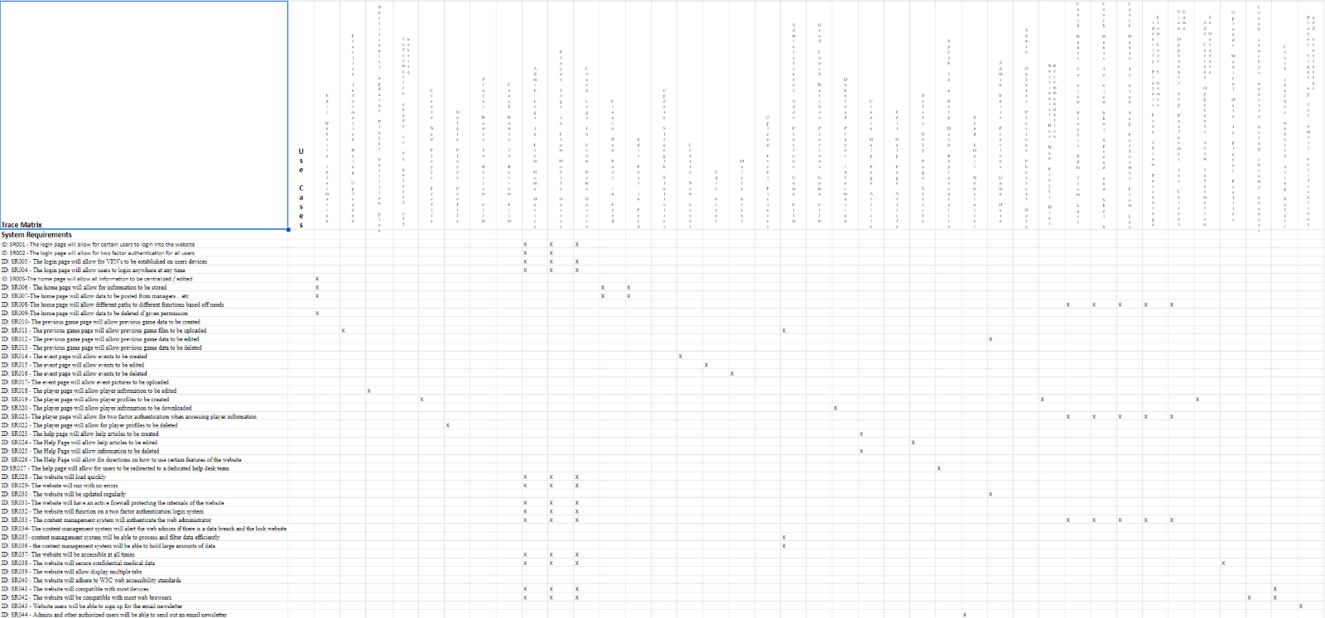

Class Diagram

This class diagram was derived using verb-noun analysis. This shows how use cases flow andcreates the attributes from nouns, and the methods from verbs. When viewing this class diagram,there are relationships between each class that can be seen. The relationship between these classes will help illustrate how many objects are associated between the classes. Each classis made up of attributes (characteristics) and methods (what the object can do). The two main classes in this diagram are the coach and the administrator. There is one administrator formany of the classes. The administrator can edit different website pages and forms, edit stats, accept or deny changes made to the website, create profiles for players, send newsletters, create events, and more. The coaches can interact with all of the different forms. The other classes include forms, newsletters, website pages, FILL THIS IN, player profiles, and more. There are also some classes that are denoted as “IsPartOf”. These are classes with an aggregation relationship. These classes are part of another class.

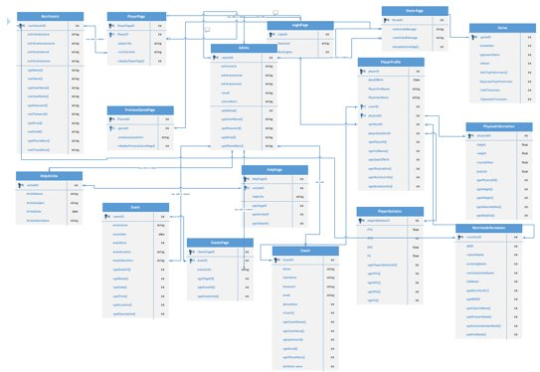

Database Diagram



To achieve third normal form, partial dependencies and transitive dependencies were removed. Many tables contained partial dependencies where data about the customer could be determined by only the Customer ID. Those attributes were removed and then added to the Website User tab

Database Definitions

**Log in Page**

|  |  |  |  |  |
| --- | --- | --- | --- | --- |
| Attribute | Definition | Type | Size | Key |
| PageID | Unique identifier for the page | Unsigned Long | 4 bytes | Primary |

**Home Page**

|  |  |  |  |  |
| --- | --- | --- | --- | --- |
| Attribute | Definition | Type | Size | Key |
| PageID | Unique identifier for the page | Unsigned Long | 4 bytes | Primary |
| WelcomeMessage | Welcomes user to page | string | 400 bytes | No |
| NewsFeedMessage | Displays latest news | string | 400 bytes | No |

**Previous Game Page**

|  |  |  |  |  |
| --- | --- | --- | --- | --- |
| Attribute | Definition | Type | Size | Key |
| PageID | Unique identifier for the page | Unsigned Long | 4 bytes | Primary |
| GameID | Unique identifier for the game | Unsigned Long | 4 bytes | Foreign |
| PreviousGameInformation | Information regarding previous games | string | 400 bytes | no |

**Game**

|  |  |  |  |  |
| --- | --- | --- | --- | --- |
| Attribute | Definition | Type | Size | Key |
| GameID | Unique identifier for the game | Unsigned Long | 4 bytes | Primary |
| Date | Date of the game | Date | 3 bytes | no |
| Opponent Team | Opponent team name | String | 255 bytes | no |
| Referee | Name of referee | String | 255 bytes | no |
| UofLTopPerformers(PlayerID) | PlayerID of top UofL performers | Unsigned Long | 4 bytes | Foreign Key |
| OpponentTopPerformers | Names of top opponent performers | String | 400 bytes | no |
| UofLTurnovers | Number of Uofl Turnovers | Integer | 4 bytes | no |
| OpponentTurnovers | Number of opponent Turnovers | Integer | 4 bytes | no |

**Player Page**

|  |  |  |  |  |
| --- | --- | --- | --- | --- |
| Attribute | Definition | Type | Size | Key |
| PageID | Unique identifier for the page | Unsigned Long | 4 bytes | Primary |
| Player Page Information | Information regarding player profiles | string | 400 bytes | no |

**Player Profile**

|  |  |  |  |  |
| --- | --- | --- | --- | --- |
| Attribute | Definition | Type | Size | Key |
| PlayerID | Unique identifier for the player | Unsigned Long | 4 bytes | Primary |
| Date of Birth | Player’s date of birth | Date | 3 bytes | no |
| First Name | Player’s first name | string | 255 bytes | no |
| Last Name | Player’s last name | string | 255 bytes | no |
| PhysicalID | Unique identifier for a players physical information | Unsigned Long | 4 bytes | Foreign |
| NutritionID | Unique identifier for a players nutritional information | Unsigned Long | 4 bytes | Foreign |
| PlayerStatisticsID | Unique Identifier for a players statistics information | Unsigned Long | 4 bytes | Foreign |

**Physical Information**

|  |  |  |  |  |
| --- | --- | --- | --- | --- |
| Attribute | Definition | Type | Size | Key |
| PhysicalID | Unique identifier for a player’s physical information | Unsigned Long | 4 bytes | Primary |
| Height | Player’s height | Float | 4 bytes | no |
| Weight | Player’s weight | Float | 4 bytes | no |
| MuscleMass | Player’s muscle mass weight | Float | 4 bytes | no |
| BodyFat | Player’s body fat percentage | Float | 4 bytes | no |

**Nutrition Information**

|  |  |  |  |  |
| --- | --- | --- | --- | --- |
| Attribute | Definition | Type | Size | Key |
| NutritionID | Unique identifier for a player’s nutritional information | Unsigned Long | 4 bytes | Primary |
| BMR | Player’s base metabolic rate | Integer | 4 bytes | no |
| CaloricNeeds | Player’s caloric needs in Kilocalories | Integer | 4 bytes | no |
| ProteinNeeds | Player’s protein needs in grams | Integer | 4 bytes | no |
| CarbohydratesNeeds | Player’s carbohydrate needs in grams | Integer | 4 bytes | no |
| FatNeeds | Player’s fat needs in grams | Integer | 4 bytes | no |

**Player Statistics**

|  |  |  |  |  |
| --- | --- | --- | --- | --- |
| Attribute | Definition | Type | Size | Key |
| PlayerStatisticsID | Unique identifier for the player statistics | Unsigned Long | 4 bytes | Primary |
| PPG | Player’s points per game | Float | 4 bytes | no |
| APG | Player’s averages per game | Integer | 4 bytes | no |
| RPG | Player’s rebounds per game | Float | 4 bytes | no |
| FG | Player’s field goals percentage | Float | 4 bytes | no |

**Events Page**

|  |  |  |  |  |
| --- | --- | --- | --- | --- |
| Attribute | Definition | Type | Size | Key |
| PageID | Unique identifier for the page | Unsigned Long | 4 bytes | Primary |
| EventID | Unique identifier for an event | Unsigned Long | 4 bytes | Foreign |
| EventsInfo | Information regarding events | string | 400 bytes | no |

**Event**

|  |  |  |  |  |
| --- | --- | --- | --- | --- |
| Attribute | Definition | Type | Size | Key |
| EventID | Unique identifier for an event | Unsigned Long | 4 bytes | Primary |
| Name | Name of the event | string | 255 bytes | no |
| Date | Date of the event | date | 3 bytes | no |
| Time | Time of the event | int | 4 bytes | no |
| Location | Location of the event | string | 255 bytes | no |
| Description | Description | string | 400 bytes | no |

**Coach**

|  |  |  |  |  |
| --- | --- | --- | --- | --- |
| Attribute | Definition | Type | Size | Key |
| CoachID | Unique identifier for the coach | Unsigned Long | 4 bytes | Primary |
| Name | Coaches’ name | string | 255 bytes | no |
| Username | Coaches’ login username | string | 255 bytes | no |
| Password | Coaches’ login password | string | 255 bytes | no |
| Email | Coaches’ email | string | 255 bytes | no |
| PhoneNum | Coaches’ phone number | integer | 4 bytes | no |

**Nutritionist**

|  |  |  |  |  |
| --- | --- | --- | --- | --- |
| Attribute | Definition | Type | Size | Key |
| NutritionistID | Unique identifier for the nutritionist | Unsigned Long | 4 bytes | Primary |
| Name | Nutritionist’s name | string | 255 bytes | no |
| Username | Nutritionist’s login username | string | 255 bytes | no |
| Password | Nutritionist’s login password | string | 255 bytes | no |
| Email | Nutritionist’s email | string | 255 bytes | no |
| PhoneNum | Nutritionist’s phone number | integer | 4 bytes | no |

**Admin**

|  |  |  |  |  |
| --- | --- | --- | --- | --- |
| Attribute | Definition | Type | Size | Key |
| AdminID | Unique identifier for the admin | Unsigned Long | 4 bytes | Primary |
| Name | Admin’s name | string | 255 bytes | no |
| Username | Admin’s login username | string | 255 bytes | no |
| Password | Admin’s login password | string | 255 bytes | no |
| Email | Admin’s email | string | 255 bytes | no |
| PhoneNum | Admin’s phone number | integer | 4 bytes | no |

**Help Page**

|  |  |  |  |  |
| --- | --- | --- | --- | --- |
| Attribute | Definition | Type | Size | Key |
| PageID | Unique identifier for the page | Unsigned Long | 4 bytes | Primary |
| ArticleID | Unique identifier for a help article | Unsigned Long | 4 bytes | Foreign |
| HelpInfo | Information regarding help articles | string | 400 bytes | no |

**Help Article**

|  |  |  |  |  |
| --- | --- | --- | --- | --- |
| Attribute | Definition | Type | Size | Key |
| ArticleID | Unique identifier for a help article | Unsigned Long | 4 bytes | Primary |
| Name | Article’s name | string | 255 bytes | no |
| Subject | Article’s subject | string | 255 bytes | no |
| Date | Article’s date | date | 3 bytes | no |
| Description | Article’s brief description | string | 400 bytes | no |

**User Interface Navigation Diagram and Screen Layouts**

User Interface Navigation Diagrams show users how they will navigate through the website, the steps that they will take to go through to get to each page in the website and how each page relates to another.

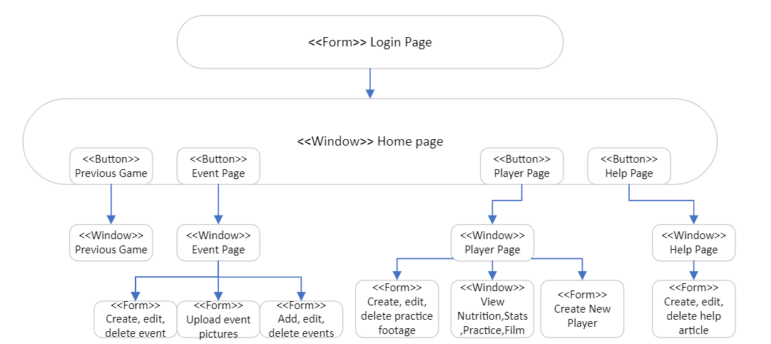

**Data Capture Forms**

These are mockups of the input forms for the new Men's Basketball Website's screen layout. Each of the use cases and prototypes shown is meant to illustrate what the administrator / stakeholders should see when they access and utilize the website.

**Information needs to be deleted off home page, Create and Edit Post in Feed**

When administrators log in to the website to work on the home page for the UofL men's basketball team, they will encounter this screen. As the home page is the primary source of information for the team, it is crucial that the administrators handle it with care to ensure that accurate and up-to-date information is presented. In the case of needing to delete information from the website, the risk level is high, as outdated or incorrect information can mislead or confuse stakeholders Therefore, the administrators must take prompt action to remove any such information to maintain the website's credibility.

The news feed is a vital element for the UofL men's basketball website to communicate information about upcoming events, player updates, and news about the team. The news feed must be regularly updated, and the website administrator will be responsible for this task. The administrator will create new posts on the news feed when new information needs to be shared and will have the ability to edit or delete the posts as needed to maintain accuracy and credibility.

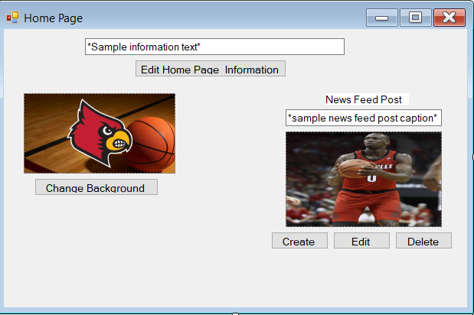

**Create,Edit, and Delete Event**

Events are an essential part of the UofL men's basketball team's mission to engage with fans and promote the team's games and activities. The website serves as an important tool for the team to advertise and promote its events to potential attendees. Therefore, creating, editing, and deleting events on the website is crucial to ensuring that stakeholders have accurate and up-to-date information about the team's games and player stats.

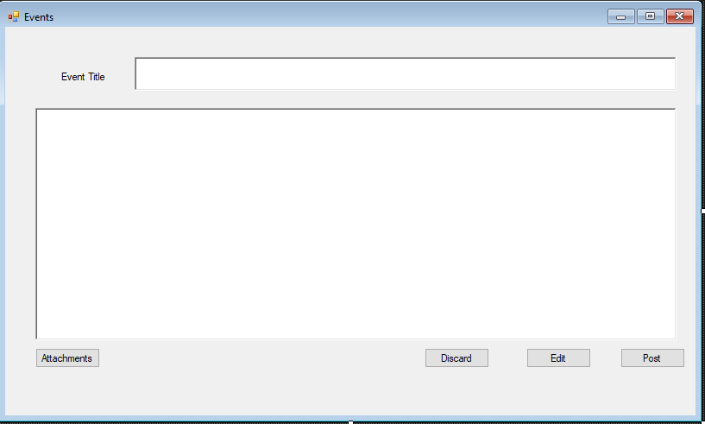

**Upload Event Pictures**



**Create, Edit, and Delete Help Page article**

The Help Page is an important part of the Uofl men's basketball team's website, providing users with essential information on how to navigate and use the website. The Help Page will include instructions on how to access important features of the website, such as event calendars, news feeds, and player profiles It is crucial that the Help Page is regularly updated to ensure that users have access to the latest information and that any issues or questions are addressed promptly. The Help Page will be accessible to administrators for editing and creating new content, ensuring that it remains relevant and up-to-date.

The administrator must have the correct credentials to access this portion of the website and will be responsible for ensuring that the information provided is accurate and helpful. By maintaining an informative and accessible Help Page, the Uofl men's basketball team can provide users with the best possible experience when using their website.

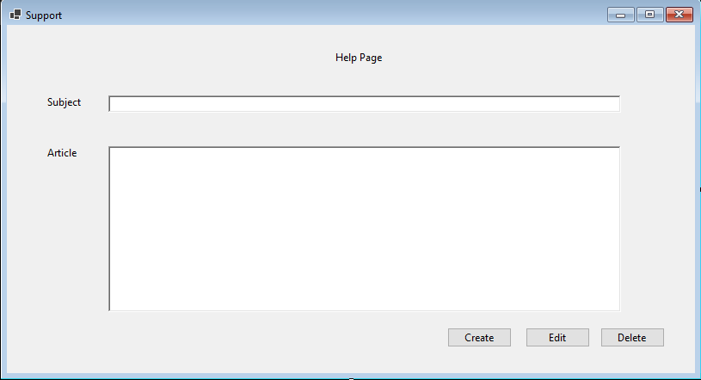

**Upload, Edit, Delete Practice Footage**

UofL men's basketball website because it allows them to manage the content that is uploaded to the website. By using this use case, the administrator can upload new practice footage of the team, edit or remove existing footage as needed, and ensure that the website is always up-to-date with the latest content.

This use case is particularly important for the website, as it will provide stakeholders with the latest updates and highlights of the team's performance. The administrator can use this use case to keep the website current with the most recent practice footage, which can help to generate more interest and engagement from fans.

Additionally, this use case can help to ensure that any outdated or incorrect practice footage is removed from the website, which can help to prevent confusion or misinformation from being disseminated to fans. This can also help to maintain the credibility and reputation of the team.

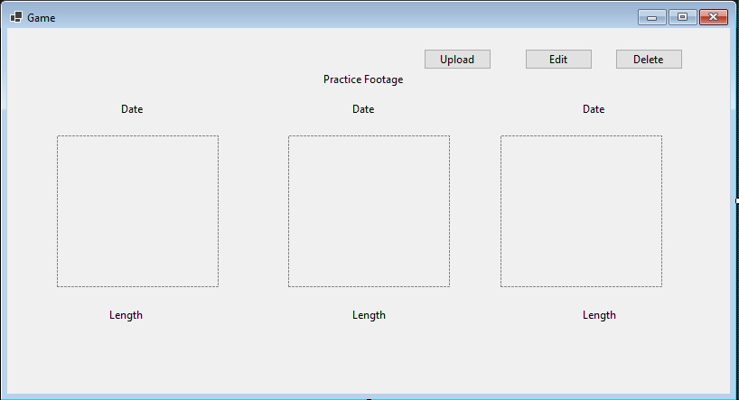

**Edit Events Page Information, and Add, Edit, Delete Events**

The Edit Events Page Information, and Add, Edit, Delete Events use cases allow the administrator of the UofL Men's Basketball website to manage the events page by creating, editing, and deleting events. This is important for keeping the website up-to-date and informing stakeholders about upcoming events related to the basketball team. The administrator can also edit the information related to the events page, ensuring that the correct and relevant information is presented to the website visitors. These use cases provide a way for the administrator to easily manage the events page, which is a key aspect of the website.



**Create, Edit, Delete Player Profile**

The player profile admin view allows the administrator to manage the player profile page by creating, editing, or deleting existing player profiles. An adming can select a player profile from the list and then select either edit to edit any attributes of a player profile such as First and Last name or weight, or select delete in order to delete the profile. If the admin selects create they will be brought to a new screen where they will be able to add all the player information and create a new profile.

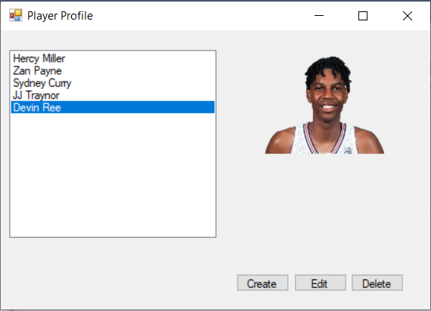

Use Interface Prototypes

Use Case 1: Edit Homepage Information



Use Case 2: Practice Information Being Uploaded



Use Case 3: Nutritionist updates Player nutrition plan

Use Case 4 & 5: Player Wants to review Film, Coach Wants to Review Film

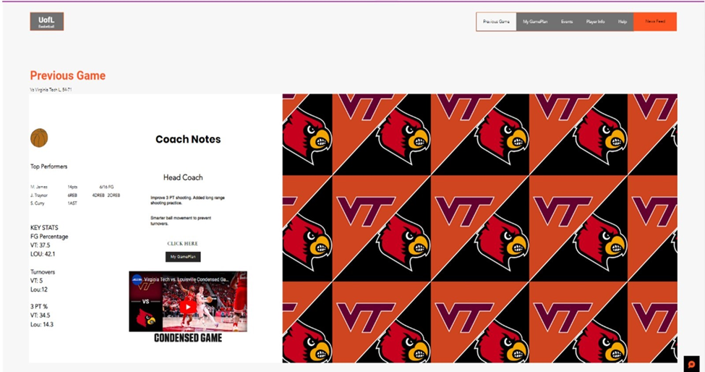

Use Case 6, 7 & 8: Admin needs to login from Home Device, Player wants to login from Home device,Coach wants to login from home device

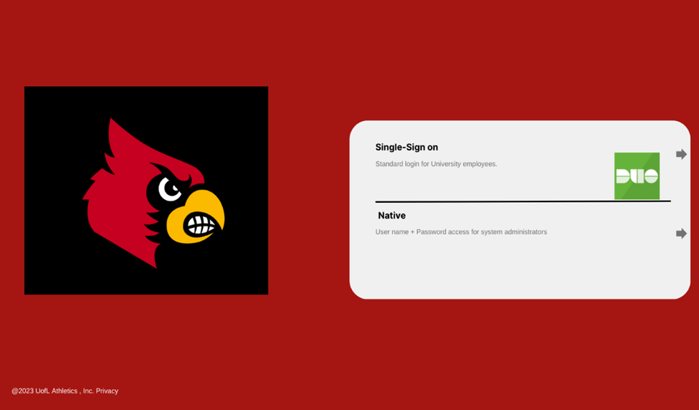

Use Case 9 & 10: Create New Post in Feed, Edit Post in Feed



Use Case 11, 12: Update Strength Statistics, Admin Uploads Medical Data To Player Profiles



Use Case 13, 14, 15, 16: Create New Event, Edit Event, Delete Event, Upload Event Pictures



Use Case 17, 13: Administrator Adds Film, Head Coach watches film



Use case 19: Coach watches film



Use Case 20: Download Player Information

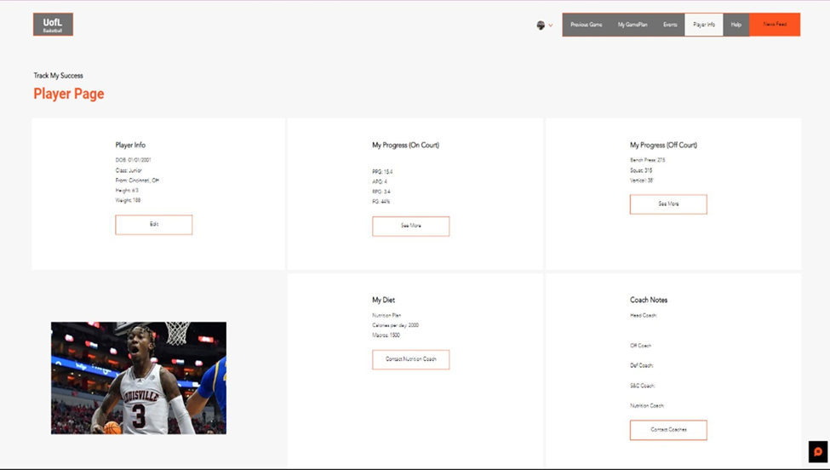

Use Case 21, 22, 23: Create,Edit, & Delete Help Page Article



Use Case 24, 25: Coach wants to view players stats from last 5 games, Coach wants to view shot spread and shot selection



Use Case 26: Coach wants to view top performer from last game



Use Case 27: Coach Wants To View Opponents Top Performer for Current Game

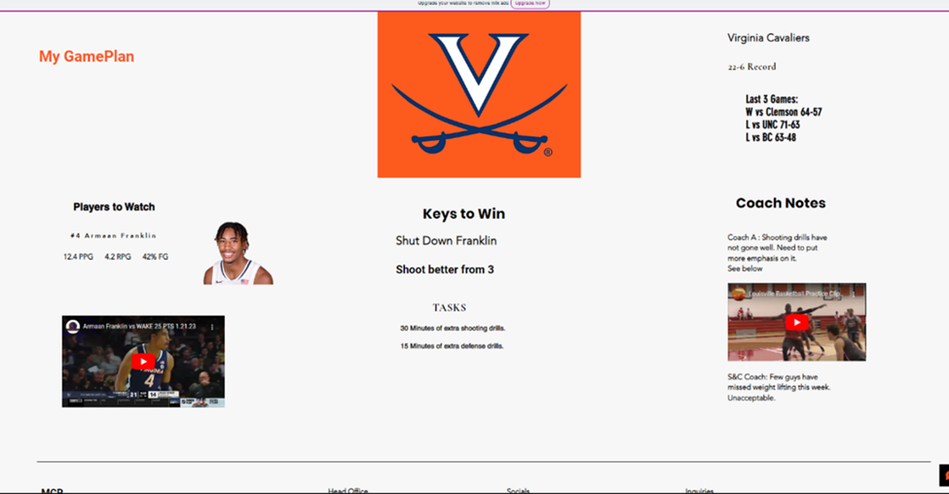

Use Case 28, 29, 30: Upload, Edit, Delete Practice Footage



**Gantt Chart**

[**Gantt Chart**](https://cardmaillouisville.sharepoint.com/:x:/s/CIS320-TEAMACE/Ef3J8ETwTudDjyWB41wBtlsBFyygZZdzG9kJeIV0sv6NDw?wdLOR=c35A258E7-8FB4-412D-BD89-42651D6F28AE)

The Gantt Chart shows the flow of activities which will be done by the team. Each red bar represents an activity and the span of time which it will take to be achieved.

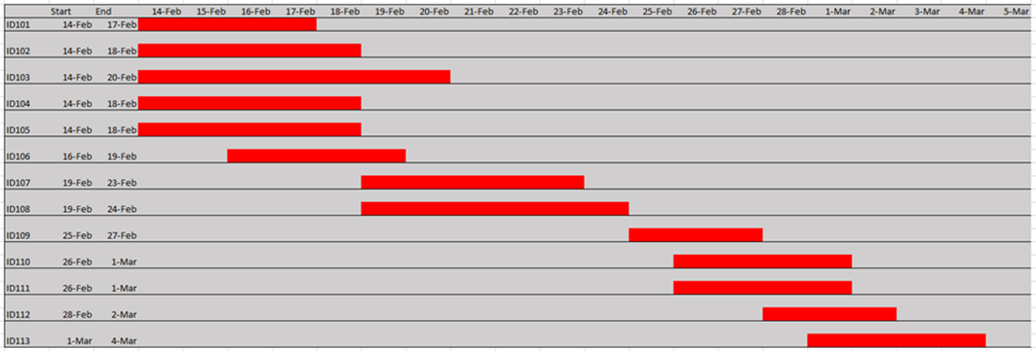 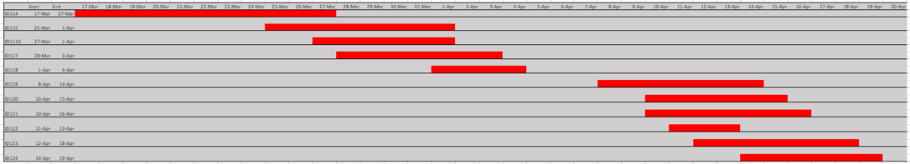

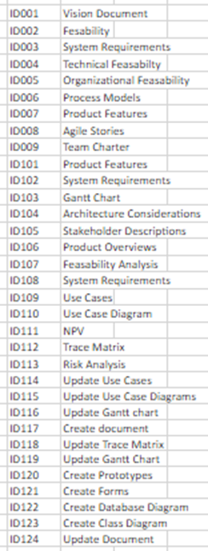

**Cost Benefit Analysis**

The Cost Benefit Analysis shows the revenue of the project against the costs of the project. We estimate profits to be over $9 million. We have come upon this estimation using estimations of yearly increases in the major sources of revenue for the Louisville men’s basketball team. We have used the ten year treasuy bill rate of 4% to discount our cashflows.

